**InsightStream: Navigate the News Landscape**

**Ideation Phase**

**Brainstorm & Idea Prioritization**

| Date | 7 march 2025 |
| --- | --- |
| Team ID | SWT1D1741164806148446 |
| Project Name | InsightStream |
| Maximum Marks | 4 Marks |

**Step-1: Team Gathering, Collaboration and Select the Problem Statement**

**Step-2: Brainstorm, Idea Listing and Grouping**

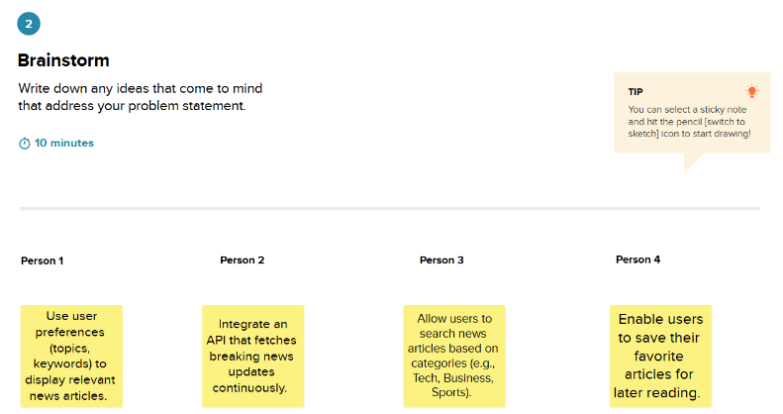

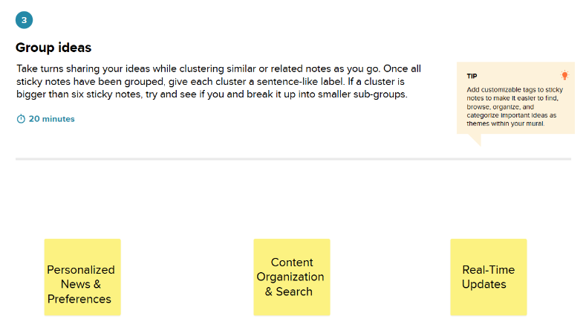

**Step-3: Idea Prioritization**

